Table of Contents

How it all Began 1
Today's Department 2
Who is a Volunteer Firefighter? 3
Why Volunteer? 4
Who can apply? 5
How do I apply? 6
What benefits do I receive? 7
How will I be trained? 8
From the Deputy Chief 9

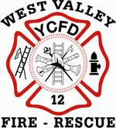

HOW IT ALL BEGAN…

THE DISTRICT

Yakima County Fire Protection District 12 was organized in 1960 with three elected Fire Commissioners. The Fire District started with two rented buildings the first year to house a fire engine in each. In 1962 a third station was constructed on donated land and in 1964 a fourth station was built. The Fire District encompassed 60 square miles of land at that time and the assessed valuation was approximately 8 million dollars. In the first year of service the District responded to 60 alarms. The Fire District has always employed a career chief. In the first Chief’s initial year, he led 24 volunteers.

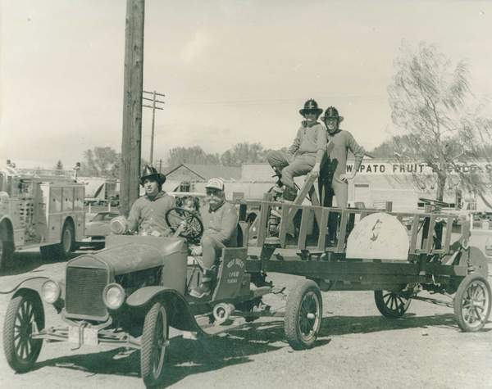

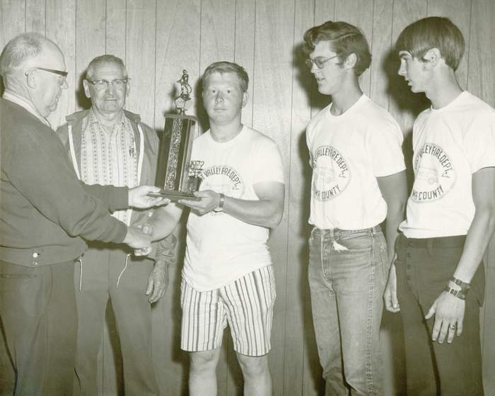
TODAY’S DEPARTMENT

Today the District employs 82 professional firefighters, 4 captains, 11 lieutenants and 5 career staff that respond to over 800 alarms a year. Three of the original stations have been replaced, the fourth remodeled and property has been purchased for a fifth administrative multi-agency facility. The annual budget is over 1.4 million dollars with 90 square miles serving over 14,000 customers. The District provides basic life-support emergency medical care services and is transport capable. All paramedic-level transports are provided by two private services based in the City of Yakima. EMS calls represent 70 % of the total call volume.

The District has a fire cadet program with the local AAA High School. There are three grade schools and one High School in the District that participate in our fire prevention programs. There are five command vehicles, eight engines, two tenders, two rescue/transport vehicles, seven brush engines, two tenders, one air cascade/rehab truck and one utility vehicle.

The District has strong inter-agency ties with the U.S. Forest Service and State Department of Natural Resources. Two wildland engines are jointly staffed during the wildfire season. Seventy-five percent of the District's members are Certified Emergency Medical Technicians and 80 percent are "red carded" wildland firefighters. The department is active in State Management Teams, State Mobilization and Project Fires throughout the state

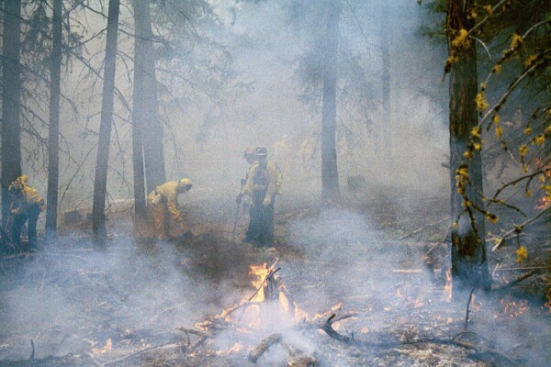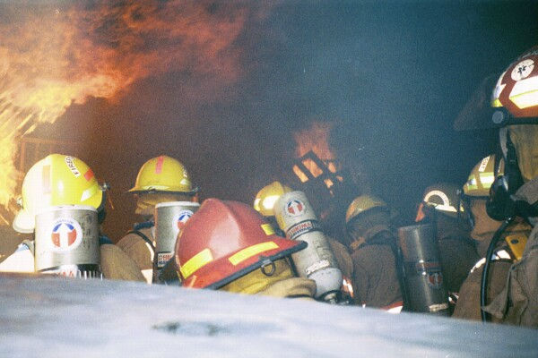

WHO IS A VOLUNTEER FIREFIGHTER?

The Volunteer firefighter is …..

A teacher, student, farmer, businessman, nurse, carpenter, office worker, etc.

Someone who makes a personal sacrifice to time.

- Someone performing in a firefighting capacity not for any monetary reward but purely for the satisfaction of helping others.

- Someone who performs well under pressure and finds difficult situations challenging.

- Someone who wants to make a contribution to his or her community.

- Someone who is gratified by the simple words, “thank you”.

- Someone who finds social satisfaction is being a part of a group of people bound together as a team.

- Someone who is willing to roll out in the middle of the coldest night when a home is threatened.

- Someone to whom a child can look up to as an educator and friend.

- Someone who inspires others with dedication, selflessness, and dependability.

- Someone who goes beyond normal daily activities into the realm of serving whenever needed.

That someone could be you!

WHY VOLUNTEER?

Why not?

Ask any volunteer firefighter why they accepted the challenge. What was the cornerstone of their decision to become a firefighter? Each one will tell you, in his/her own words that being a volunteer firefighter satisfies the need to contribute to a worthwhile endeavor while helping others.

We all have a need to feel important. We want to accomplish certain goals and grow as a person. We need challenge in our lives, excitement in the midst of the daily routine, and a chance to form new and lasting friendships with people who share a common goal.

Volunteer firefighting provides many opportunities. You will enjoy a sense of achievement, increased self-respect, community and personal recognition, the rewards that come from helping others and the opportunity to perfect some skills and learn new ones.

The rewards are many—but firefighting still requires hard work. It is very demanding. There are hours of training involved, requirements to be met, standards and professionalism to uphold.

There is, however a payoff. The “payoff” comes from the pride you will have in yourself and in our organization. It comes from the feelings of friendship and teamwork. It is the hardy handshake of a grateful homeowner, a mother’s tears of gratitude, children’s awe as they see the inside of a fire truck and talk to real firefighters, the tremendous sense of fatigue in doing something worthwhile and the thankful smile of a neighbor in the community.

Why volunteer? Look inside yourself. You will find the answer.

Volunteer firefighting will never make you monetarily rich, but will make you rich in many other ways.

WHO CAN APPLY?

Applicants for the position of volunteer firefighter must be older than 18 and should be in good physical and mental health. You must posses a current Washington State driver's license, High School Diploma or GED and have a good driving record.

Although it is preferred that applicants reside within the boundaries of Yakima Fire District 12, you are welcome to apply if you reside outside of the district. Each application will be reviewed individually.

A question often asked by prospective applicants is, “Will I have to be able to leave work or school and be available 24 hours a day?” The answer is “No.” General availability is preferred, yet the Fire District understands individuals may be in a work or school setting that prohibits their response to every incident. Your availability at other times is necessary and appreciated. Staffing needs, availability, and work schedules are evaluated during the selection process on an individual basis.

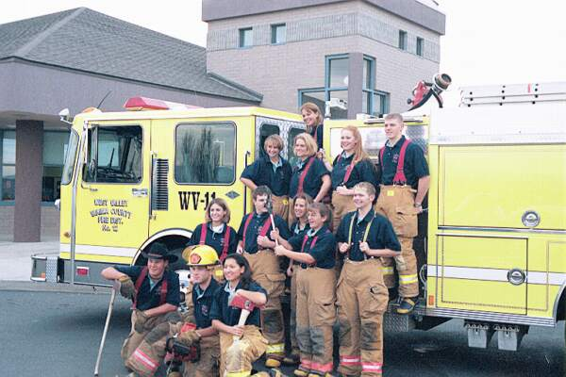
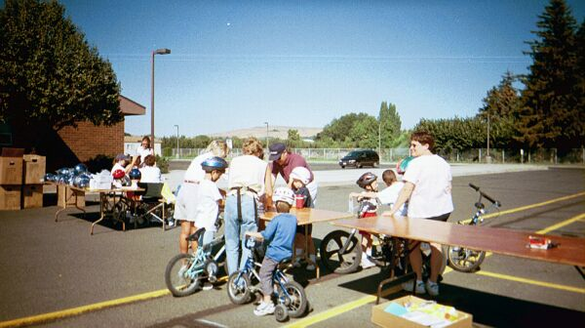

HOW DO I APPLY?

You are required to file an application with Administration and an application committee will review your application and conduct a personal interview.

Your application is reviewed, and qualified applicants are asked to complete an interview process. You will meet with the members of the application committee and a member of the command staff.

The application committee will conduct an investigation into your background. If you are selected by the application committee to become a probationary firefighter, your application will be forwarded to Chief.

Becoming a member of the Yakima Fire District 12 team requires careful selection. The selection process is designed to help the district find the men and women who would most likely become the safest and most effective firefighters on the fire ground.

If you need further information you may call or write:

West Valley Fire Department
Yakima Fire District 12
10000 Zier Rd
Yakima, WA 98908
(509) 966-3111

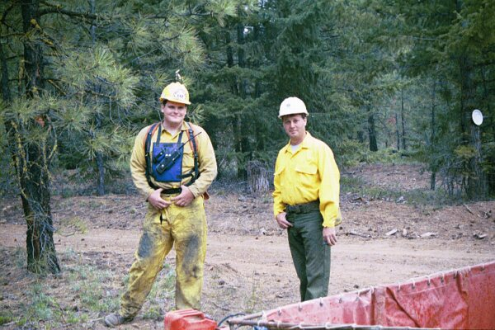

WHAT BENEFITS DO I RECEIVE?

Although the district’s primary focus is to provide services for the people in the District, as a volunteer firefighter will also receive some benefits.

The District provides you with up-to-date protective clothing and equipment. Along with clothing, you are provided with a pager, linking you to your assigned station. The Paging System will keep abreast of all incidents within your Station’s area, even if you cannot respond. The total cost of outfitting one firefighter is more than $3,000.00.

As a Firefighter, you are provided with Workman’s Compensation Insurance. All members will be enrolled in the Washington State Board for Volunteer Firefighters disability plan. The Department also carries supplemental insurance for each member. All firefighters, with the exception of cadets, have the choice of enrolling in the Relief and Pension program. All members, after the one-year probationary period, will be signed up for life insurance policy through Prudential Insurance..

Finally, the District’s training program in fire prevention and fire suppression not only benefits the community, but also becomes a priceless skill in family and personal relations. Not only are you equipped and trained to serve the public, you are ready and prepared to help those you love.

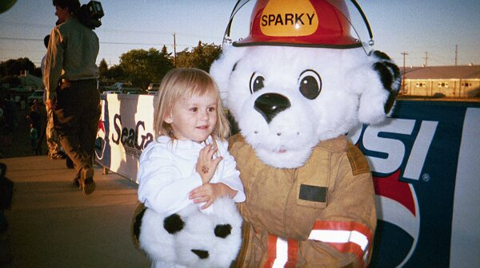

HOW WILL I BE TRAINED?

As a volunteer firefighter with the West Valley Fire Department/Yakima Fire District 12 you will receive both one-on-one and group training. At the time your application has been approved, the training begins.

After being assigned to your station and meeting your Company Officers (Captain and Lieutenant) you will be issued; protective clothing, a pager, and a Volunteer’s Handbook. The officers assigned to your station will then start the training process with you.

For a period up to twelve months, you will be considered a probationary member. As a probationary member you will not be placed in dangerous situations until the Company Officers are sure that you are capable of handling such circumstances. You will be fully checked and re-checked at each skill level to insure safety for yourself and others.

The training will take time and a commitment on your part. Training involves your participation and it involves your self-motivation. If during the training process it becomes evident that you are not making such a commitment, then you will be counseled and possibly released as a probationary member.

Training is ongoing. Serving as a firefighter means a life-long commitment to continuing education in order to stay abreast of the latest equipment and emergency procedures. There are two District-wide training sessions per month that you will be asked to participate in.

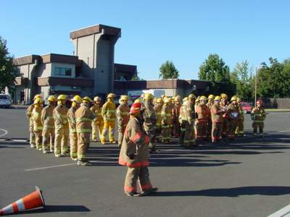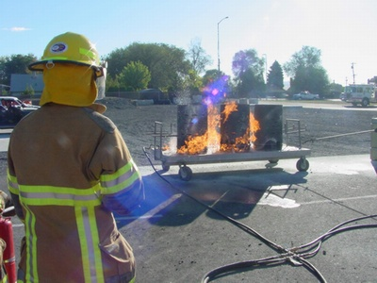

Dear Prospective Firefighter,

Thank you for showing an interest in becoming a Volunteer Firefighter with the West Valley Fire Department/Yakima Fire District 12. The Fire Service is one of the most honorable professions with strong traditions because we are charged with a tremendous responsibility. To succeed as a Firefighter you must have perseverance, dedication and ability to work safely as a team. It demands a great deal from an individual, but it gives so much back to each of us.

Our organization prepared this brochure to help answer some of the questions you might have about being a Firefighter. It also lets you know a little about us.

We are very proud of the men and women who make up the West Valley Fire Department/Yakima Fire District 12. They are highly motivated and committed to the betterment of this community.

We constantly strive to enhance and improve the level of services we provide to the citizens which reside and travel through the community. By constantly evaluating our performance, we are relentlessly improving the capabilities of the District and its personnel.

I hope this information will be of benefit to you. Should you have any further questions, please feel free to call us at 509-966-3111 or stop by Station One. We would be glad to discuss the organization and application process with you.

